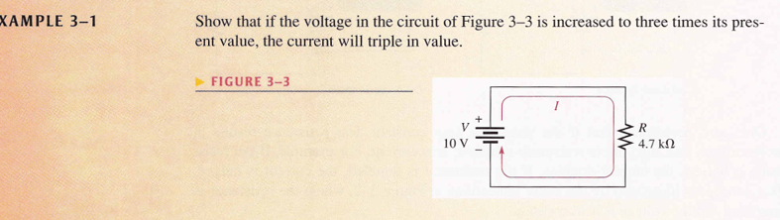

Given Data:

To Find:

Formula:



Given Data:

To Find:

Formula:

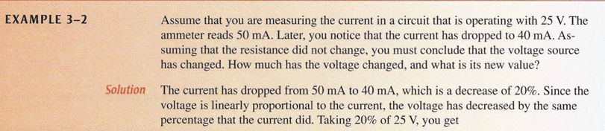

Given Data:

To Find:

Formula:



Given Data:

To Find:

Formula:

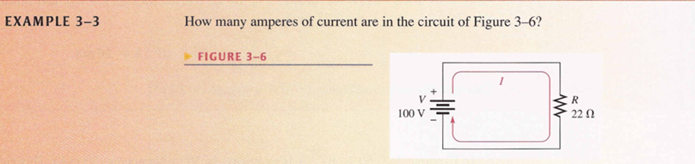

Given Data:

To Find:

Formula:

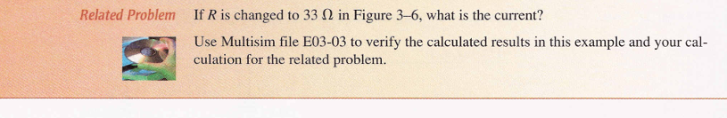

Given Data:

To Find:

Formula:

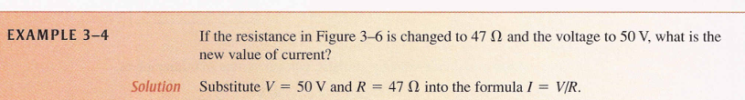

Given Data:

To Find:

Formula:



Given Data:

To Find:

Formula:

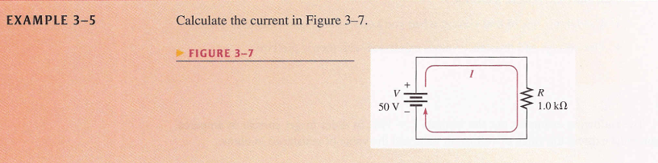

Given Data:

To Find:

Formula:



Given Data:

To Find:

Formula:

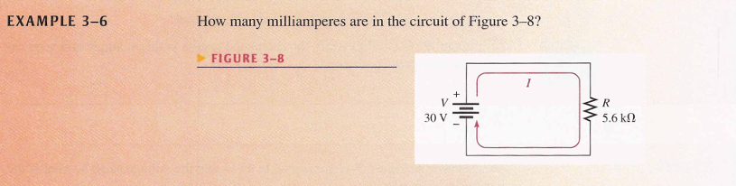

Given Data:

To Find:

Formula:

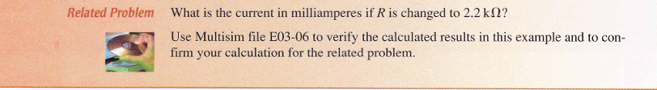

Given Data:

To Find:

Formula:

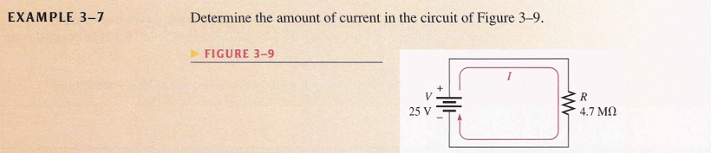

Given Data:

To Find:

Formula:



Given Data:

To Find:

Formula:



Given Data:

To Find:

Formula:



Given Data:

To Find:

Formula:



Given Data:

To Find:

Formula:



Given Data:

To Find:

Formula:



Given Data:

To Find:

Formula:

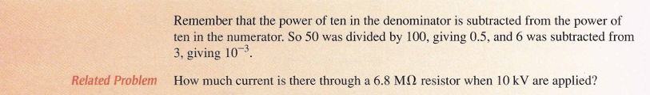

Given Data:

To Find:

Formula:

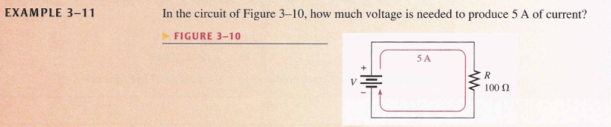

Given Data:

To Find:

Formula:



Given Data:

To Find:

Formula:

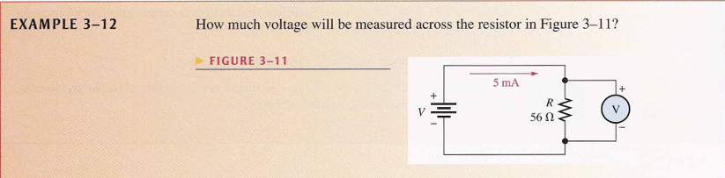

Given Data:

To Find:

Formula:

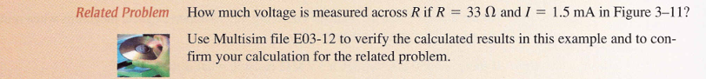

Given Data:

To Find:

Formula:

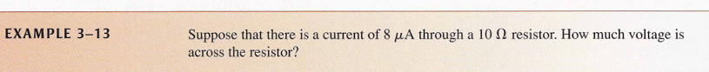

Given Data:

To Find:

Formula:



Given Data:

To Find:

Formula:

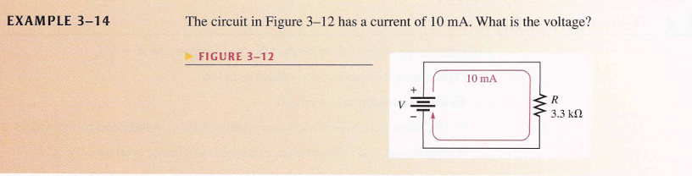

Given Data:

To Find:

Formula:



Given Data:

To Find:

Formula:



Given Data:

To Find:

Formula:



Given Data:

To Find:

Formula:

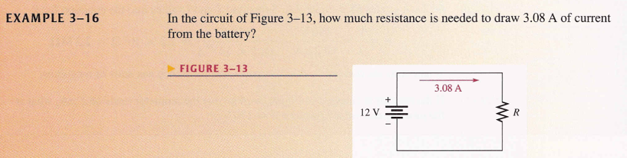

Given Data:

To Find:

Formula:



Given Data:

To Find:

Formula:

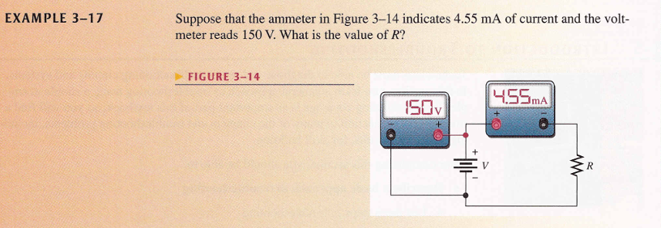

Given Data:

To Find:

Formula:

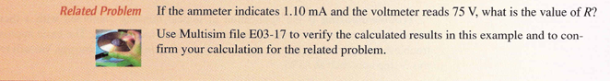

Given Data:

To Find:

Formula:



Given Data:

To Find:

Formula:



Given Data:

To Find:

Formula:



Given Data:

To Find:

Formula:



Given Data:

To Find:

Formula:



Given Data:

To Find:

Formula:



Given Data:

To Find:

Formula:



Given Data:

To Find:

Formula:



Given Data:

To Find:

Formula:

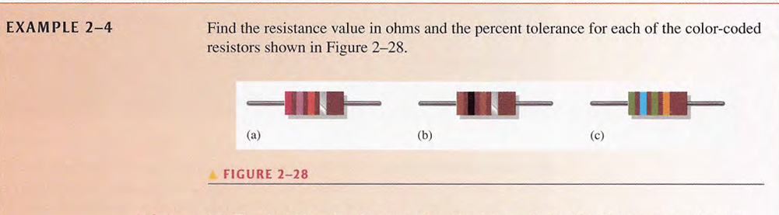

Given Data:

To Find:

Formula:

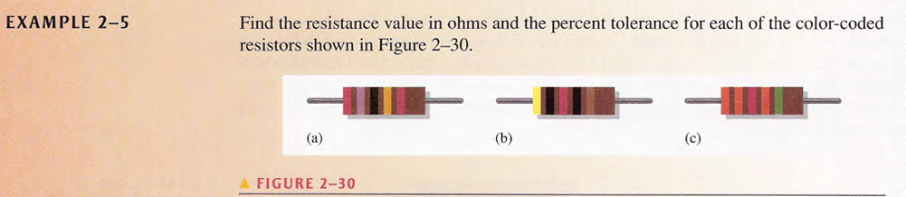

Given Data:

To Find:

Formula:

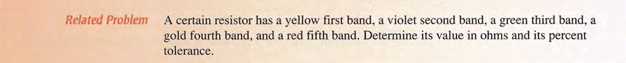

Given Data:

To Find:

Formula:



Given Data:

To Find:

Formula:



Given Data:

To Find:

Formula:



Given Data:

To Find:

Formula:



Given Data:

To Find:

Formula:



Given Data:

To Find:

Formula:

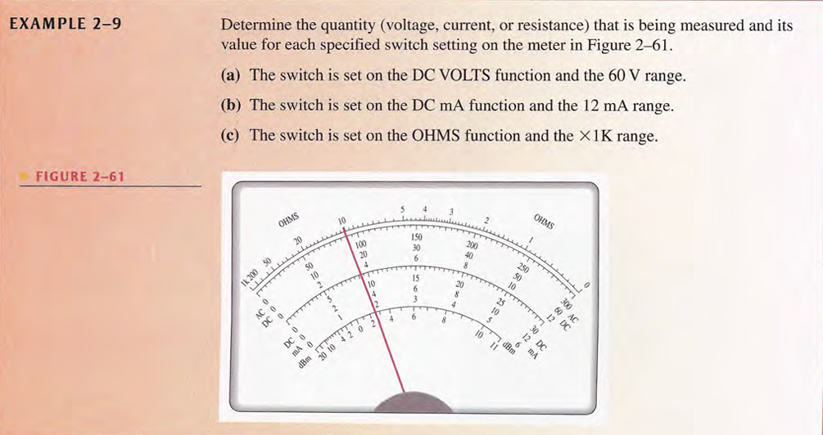

Given Data:

To Find:

Formula:

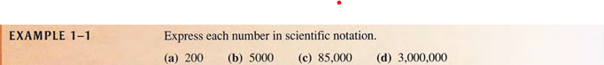

Given Data:

To Find:

Formula:



Given Data:

To Find:

Formula:



Given Data:

To Find:

Formula:



Given Data:

To Find:

Formula:



Given Data:

To Find:

Formula:



Given Data:

To Find:

Formula:



Given Data:

To Find:

Formula:



Given Data:

To Find:

Formula:



Given Data:

To Find:

Formula:



Given Data:

To Find:

Formula:



Given Data:

To Find:

Formula:



Given Data:

To Find:

Formula:



Given Data:

To Find:

Formula:



Given Data:

To Find:

Formula:



Given Data:

To Find:

Formula:

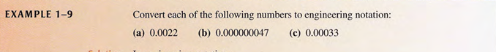

Given Data:

To Find:

Formula:



Given Data:

To Find:

Formula:



Given Data:

To Find:

Formula:



Given Data:

To Find:

Formula:



Given Data:

To Find:

Formula:



Given Data:

To Find:

Formula:



Given Data:

To Find:

Formula:



Given Data:

To Find:

Formula:



Given Data:

To Find:

Formula:



Given Data:

To Find:

Formula:



Given Data:

To Find:

Formula:



Given Data:

To Find:

Formula:



Given Data:

To Find:

Formula:



Given Data:

To Find:

Formula: